LCLS SXR User Equipment Guidelines
Document Approval (signature/date)
Name / Title | Signature | Date
Tom Benson, SXR Instrument Area Manager
William F. Schlotter, SXR Instrument Scientist
Joshua Turner, SXR Instrument Scientist

Prepared by:
W. F. Schlotter, SXR Instrument Scientist
wschlott@slac.stanford.edu
Tel: 650 926 4940

J. J. Turner, SXR Instrument Scientist
joshuat@slac.stanford.edu
Tel: 650 926 4437

Tom Benson, Instrument Area Manager
benson@slac.stanford.edu
Tel: 650 926 3710

Purpose
This document provides a list of guidelines for preparing end stations for integration at the LCLS SXR Instrument. It is separated into two sections. The first section details the conventional facility specifications that are relevant to end station integration. The second section describes requirements for endstation integration.

Conventional Facility Specifications
Crane lift points: The system may need to be lifted by crane or forklift. This will require that there are rigging points that can be used to hoist the chamber and stand as well as lift points for a fork lift.
Survey Tooling Ballsockets: The LCLS survey group is capable of aligning instruments into experimental position in hutch 2 with ~25um accuracy. Tooling balls are required on your chamber and an accurate CAD model is necessary to defining the placement position. Allow time after installation to fiducialize (align) the system with the beam.
Mass: The mass of the end station systems is limited by the freight elevator which will be used to transport the components from the loading dock to the experimental floor level. This elevator has a maximum capacity of 13,000 lbs.
Crane: The capacity of the crane is 2000lbs. The maximum hook height is 10’ 5” (3.1m) above the floor. Clearances: The following chart describes the current apertures through which the end station must pass.
Door or Aperture | Height | Width
Elevator | 2.36 m | 2.54 m
Sub-Basement Setup Lab | 2.36 m | 1.78 m
Hutch 2 Roll Up Door | 2.45 m | 3.15 m
Sub-Basement Hallway | 2.69 m (floor to lights)

Space: The most constrained area is the final location of the endstation in the hutch. The drawing below shows this area.
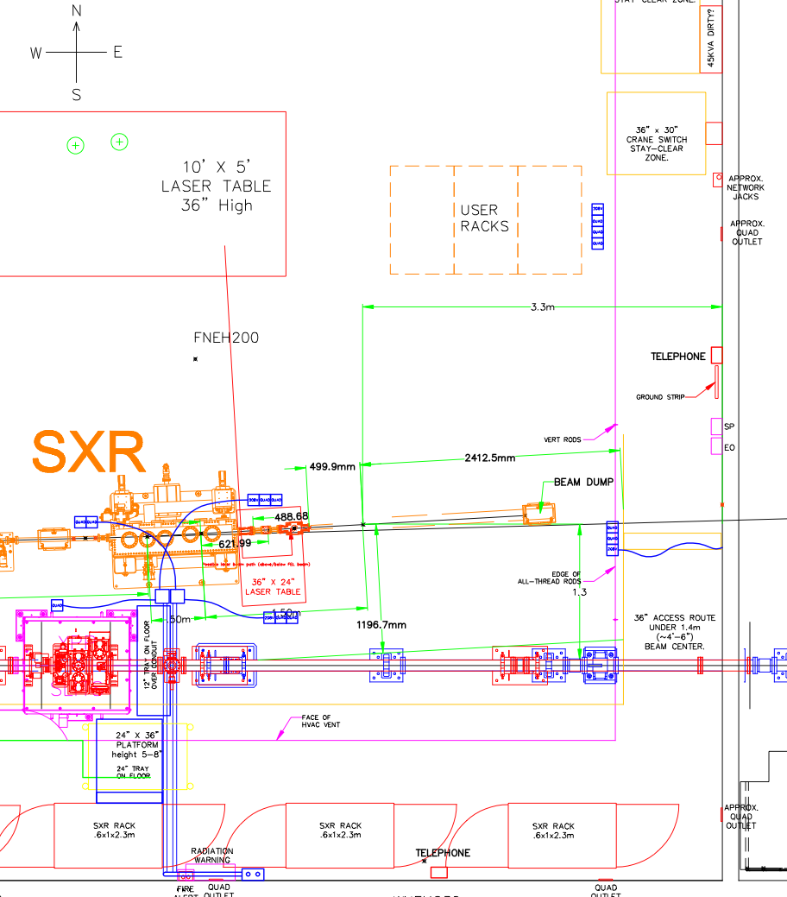
Figure 1: Detailed drawing of end station area in the SXR hutch.

Clearances:
- There is 3.8m from the exit valve to the back wall, however at least 0.9 meters of that space should be left for access, so please contact the SXR Instrument Scientist if you expect that your endstation will occupy any space that is 2.9m after the beamline exit valve.
- There is 1.0m of floor space on the south side of the beam path. This is transverse to the beam.
- There is at least 2.0m of space on the north side of the beam path. This is the side that is closer to the entrance to the hutch.
- The distance from the floor to the first vertical obstruction is 2.7 m. However must of the area is much higher.
- The smallest vertical aperture for moving the system into place is at the elevator which is 2.1 m. The width of the elevator is 2.4 m.
- The exit valve is 1.4m +-0.03 m above the floor.

Clearance Checks: The SXR instrument team would like to check for interference issues with your end station. Please send the SXR Instrument Scientist or Engineer the CAD file of your end station and we will integrate it to the master layout.
Focus: Because the KB optics are bendable there is some control over the focal position. Currently they are planned to be used only to focus at their nominal position of 0.5m downstream of the exit valve flange. If another focal position is desired please contact the SXR Instrument Scientist. The distance from the floor to the focus is 1.427 m. However there is 10 mm of variation in the height of the floor across the endstation area.
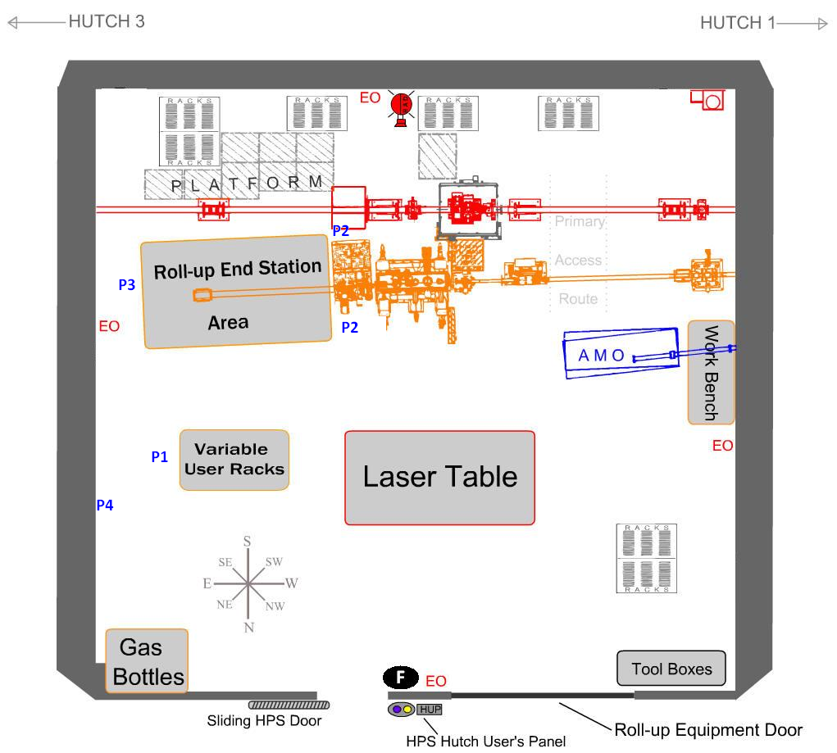
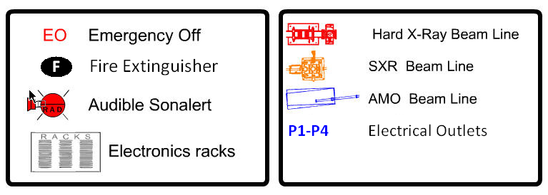
Figure 2: Functional drawing of hutch 2 space.

Power: Power will be distributed from outlets marked in blue in Figure 2.
- P1: Twelve 110V 20A outlets mounted below the cable tray above the user racks.
- P2: Sixteen 110V 20A outlets and one 208V 20A three phase outlets near the exit valve.
- P3: Eight 110V 20A outlets and one 208V 20A three phase outlets located 1.0m from the downstream wall on a flexible line.
- P4: Additionally, five 208 VAC 60 A 5 wire three phase outlets on the downstream wall. These outlets will have a NEMA L21-60 5-wire type receptacle. Contact the SXR Instrument Scientist if you plan on using these outlets.
Processed Cooling Water: The standard temperature for PCW is 25 C. A water distribution post of quick disconnect ports is available. Currently the flow capacity available for the end station is 3.9 gpm. An intermediate water to water cooling system heat exchanger can be made available.
Compressed Air: The compressed air pressure is 90 psi. There is an accumulator in the hutch to ensure that the pressure is sustained in the event of a sudden demand (eg to close gate valves). If you plan to integrate pneumatic valves to the control system this must be specified in the controls ESD, which must specify connectors.
Cryogenics: Liquid nitrogen and helium will be supplied by dewar. Please plan to account for their floor space. If you plan to use any other cryogenic liquids contact the SXR Instrument Staff. Users may be expect to support the cost of liquid helium.
Bottled Gas: High purity nitrogen will be provided from as boil-off from dewar. Normally the hutch is not set up for flammable gases but we can accommodate for them if necessary. If you plan to use toxic, flammable or otherwise hazardous gases please contact the SXR Instrument Staff.
Exhaust System: There is an exhaust manifold 2.1 meters above the floor near the end station position.
Network Connections and Wi-Fi: There are no network ports in the hutch for user computers. If a user would like to use a computer in the hutch an isolated local network must be created. Contact the SXR Instrument staff if you plan to have a networked computer in the hutch. Note however that Guest Wi-Fi and Cell phone access is available throughout the building.

End Station Integration Requirements
Earthquake (Seismic): There is an array of anchoring holes installed in the hutch floor near the end station position. Please allow space for securing chains on the stand of your chamber. Please keep all engineering documents related to the chamber and stand as a seismic review may be necessary.
Radiation Safety: Because the end station will be operated with the hutch door closed during operation the primary concern is having a sufficient beamstop. This can be a 30 cm air gap between the chamber and the wall of the hutch. The direct beam should never impinge on a viewport.
Vacuum qualification: All vacuum vessels including spectrometers, gas jet sources, etc must be inspected with an RGA scan. The partial pressures of masses 45 amu and above must be below 10e-12 torr. The RGA scans may be done in the home laboratory, preferably no earlier than 1 month before shipping, signed and deposited with Instrument Scientist.
Pumps: Only “dry pumps” are allowed at LCLS.
Vacuum online monitoring: The vacuum between the users experiment and beamline interface is monitored with an RGA. The partial pressures of masses 45 amu and above must be below 10e-11 mbar.
Interlock signals: As an interlock signal, evidence of a fully running pump and a gauge supplied by the LCLS with a set point defined by the instrument scientist, is required.
Gas and fluid lines: In all vacuum chambers with a direct vacuum connection to the beamline all fluid and gas lines must be welded. In differentially pumped sections standard fittings such as Swagelok may be tolerated, but need to be approved by the instrument scientist. VCR fittings may be permitted in vacuum with the permission of the Instrument Scientist.
Venting Safety: Burst Disks must be included in each independently ventable vacuum vessel. Over pressure relief must also be used on venting lines and can be provided. Burst disks must be MDC Vacuum Type BDA-275-ASME.
Tools: There will be a basic set of tools available in both metric and imperial sizes.
Electrical Safety: The SLAC Electrical Safety standards require that all electrical components used in the facility must be certified by a Nationally Recognized Testing Laboratory (NRTL). Note that CE is certification is not valid, but UL and TUV are. Certification can also be done at SLAC, but remember to allow extra time for this, and provide a list of the type and quantity of each component must be provided in advance.

Revision History
Revision | Date Revised | Section(s) Affected | Description of Change
R000 | June 4, 2010 | All | Original Release
R000a | May 25, 2012 | All | Original Release
R000b | June 24, 2012 | All | Moved to XFO controlled document format.

